Cyber Security Project: Bounty Hunt DVWA

_{Target Information}
- Application Name: Damn Vulnerable Web Application (DVWA)
- Deployment Type: Localhost (Lab Environment)
- Testing Type: Authorized Lab Testing
- _{Tester: Raj Kulkarni}
- _{Date of Testing: 17/01/2025}

Scope
The scope of testing was limited strictly to the DVWA application hosted locally.
All testing was performed in a controlled lab environment for educational purposes only.
In-Scope Assets:
- Web application endpoints exposed by DVWA
Out-of-Scope:
- Any external systems
- Production or real-world targets

Tools Used
- Burp Suite Community Edition
- OWASP ZAP
- SQLMap
- Nmap
- Web Browser (Firefox)
| ID | Vulnerability Type | Severity |
| ------ | --------------------------------------- | -----------------------|
| V-01 | Reflected Cross-Site Scripting (XSS) | Medium |
| V-02 | SQL Injection (Authentication Bypass) | High |

V-01: Reflected Cross-Site Scripting (XSS)

Severity: Medium

Affected Endpoint: /vulnerabilities/xss_r/

Impact
- Allows execution of arbitrary JavaScript
- Can lead to session hijacking
- Enables phishing attacks
- Could be chained with social engineering

Steps to Reproduce
- Navigate to the Reflected XSS section in DVWA
- Enter the following payload in the input field:
<script>alert('XSS')</script>
- Submit the request
- The JavaScript executes successfully in the browser
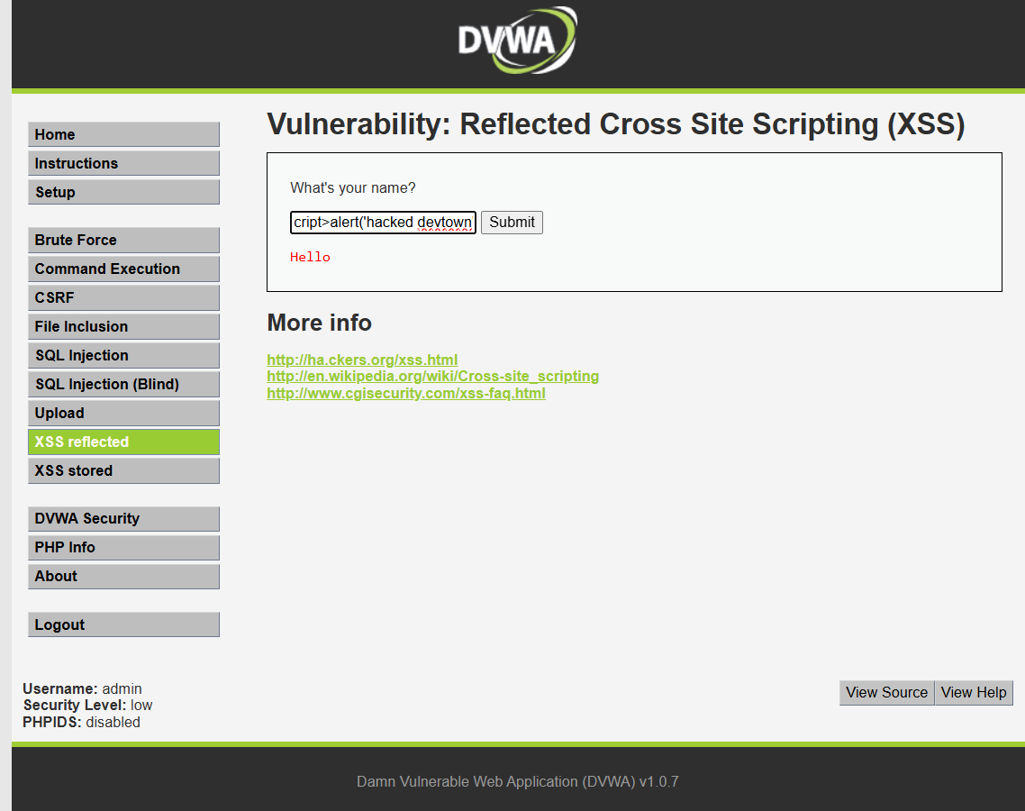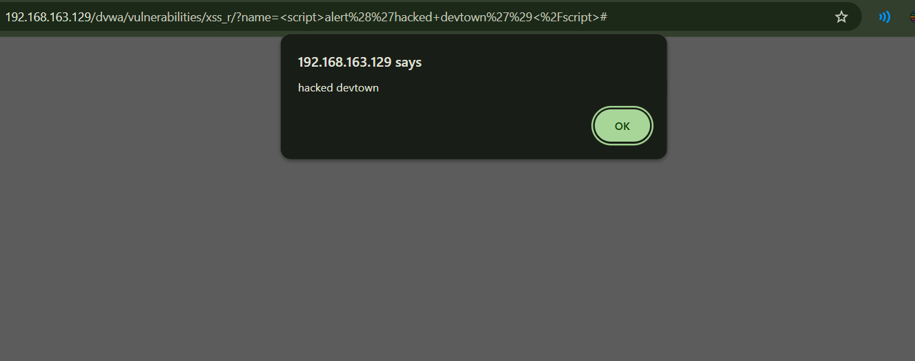

V-02: SQL Injection (Authentication Bypass)

Severity: High

Affected Endpoint: http://vulnerabilities/sqli/

Impact
- Complete database compromise
- Unauthorized data access
- Potential data modification or deletion
- Full application takeover

Steps to Reproduce
- Navigate to the SQL Injection section
- Enter the following payload in the User ID parameter:
1' OR '1'='1
- Submit the request
- Application returns user data without proper authorization

- 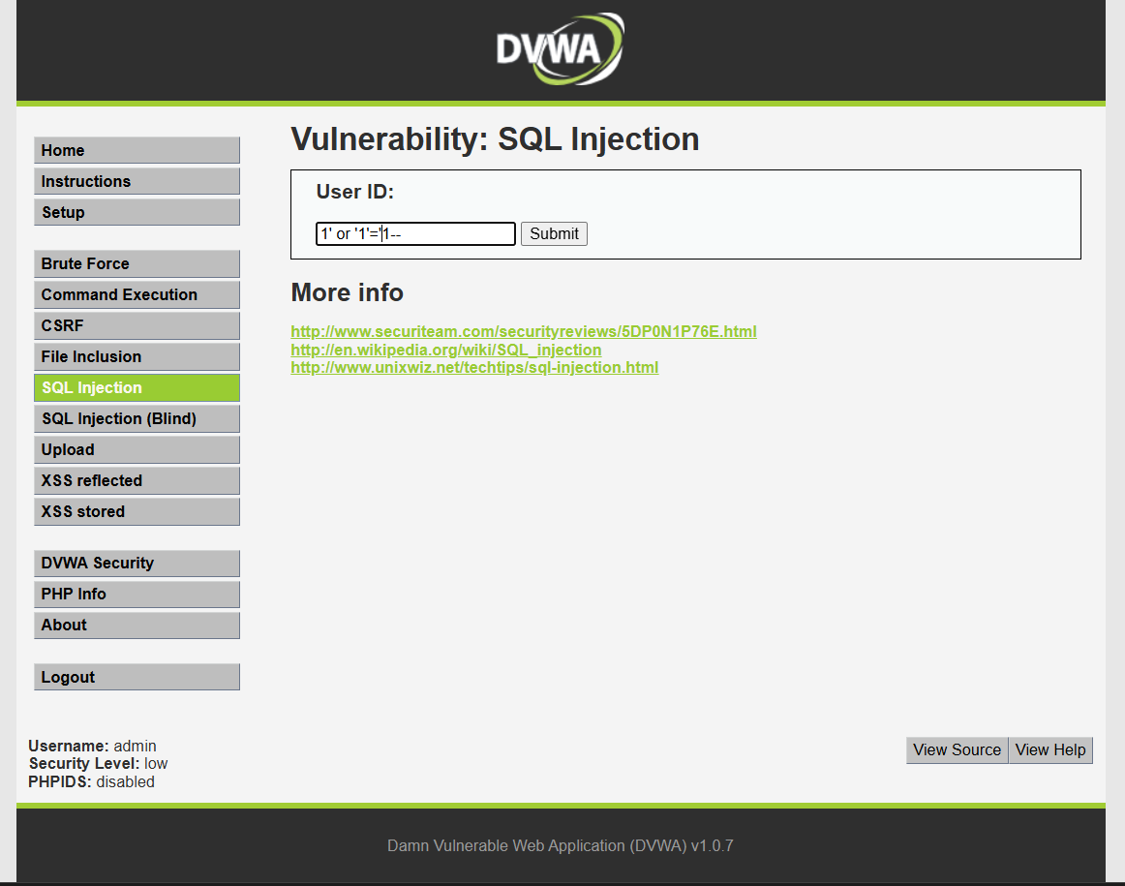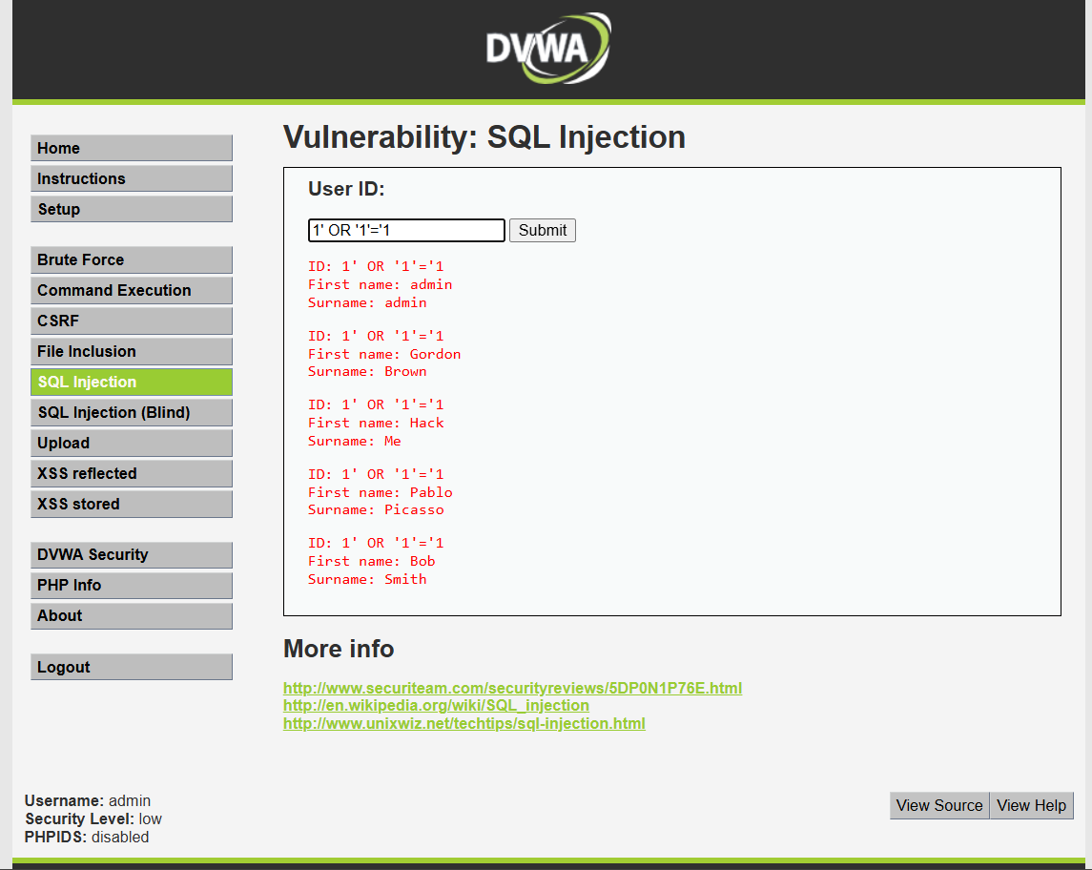
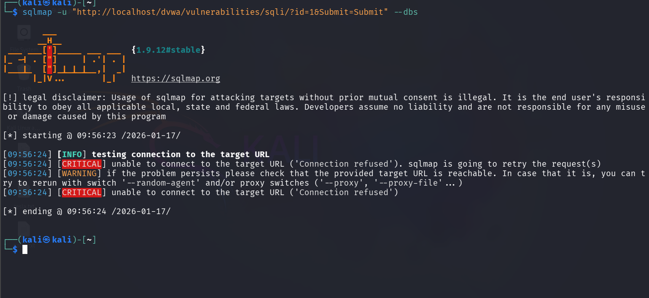

Overall Risk Assessment
The application contains multiple critical vulnerabilities that could allow an attacker to:
- Steal sensitive data
- Bypass authentication
- Execute arbitrary code in a victim’s browser
If deployed in a real-world environment, these vulnerabilities could result in severe security breaches.

Conclusion
This project successfully demonstrates the end-to-end bug bounty workflow, including reconnaissance, vulnerability identification, exploitation, and professional reporting.
All findings were responsibly documented within the defined scope.

